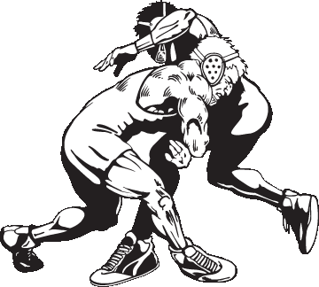
Little Huskies Wrestling Club
Sign Up Nov. 10th
6:30-7:30
Parent meeting at 7:00
Highland Wrestling Room
Practice Starts Monday Nov. 14th

Cost: Beginner (Pre-K- 2nd) $50 Advanced (3rd-8th)$65
Cost includes a T-Shirt and Our Tournament Entry Fee
Beginners: Monday 6:15-6:55
Advanced: Mondays 7:00-8:00 & Thursdays: 6:30-8:00
If you are interested in coaching, Please give Jay a call.
Questions: Contact Jay Peiffer 530-0168 or Cindy Peiffer 530-9968 or jcpeiffer@mchsi.com
-----------------------------------------Please keep top portion------------------------------------------
Child’s Name: ___________________________________________ Child’s Nick Name (if any)____________________ Grade: ______
Shirt Size (YSM-AXL)___________________
Parent(s) – Guardian(s) – Custodian(s) Name __________________________________________________________________
Phone: Home _____________________ Cell: _____________________ _________________________
*Email Address:_____________________________________________________
Emergency Contact: Person(s) who may be notified in case of emergency or illness when the above listed people are not available.
Name _____________________________________________ Phone _____________________________________________
Hospital Preference ___________________________________
If there is anyone NOT allowed to pick your child up, contact Cindy Peiffer 319-530-9968
Tournament
I understand that I (or another adult) am required to work at least 1 shift per child at our home tournament. Signature___________________________________________

Consent In the event that my child may require medical care while I am unable to be reached, I hereby give consent to Highland Little Huskies Wrestling Club’s coaches to act on my behalf to authorize medical and/or surgical treatment for my child. I agree to pay all costs and fees contingent on any emergency medical care and/ or treatment for my child as secured or authorized under this consent. You, as a parent, are liable for anything that happens to your child while at practice.
Signature:__________________________________________________________

Win or Learn, Never Lose!

