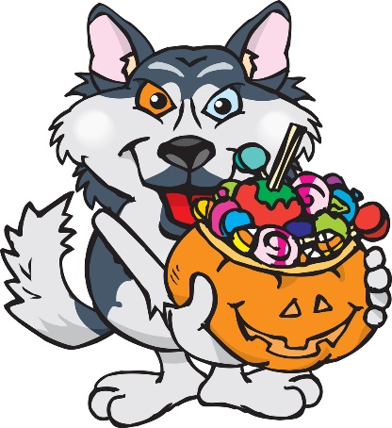
Trunk or Treat
Sunday Oct. 30th
4:00 at Riverside Elementary
Games, Hayrack Ride,
Hot Cocoa, Cookies, and FUN!

*Decorate the back of your vehicle however you wish. Bring enough candy for about 100 kids. The kids can come in their costume. It’s gonna be a great time!
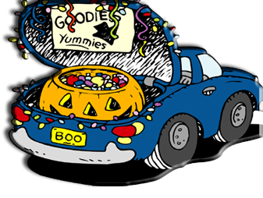
* Line up will begin at 3:45.
*All children must be supervised by an adult.
*A trophy will be awarded to the favorite vehicle, voted on by the kids.
*Questions may be directed to any ESO member or the ESO Facebook Page.
Hosted by Riverside ESO

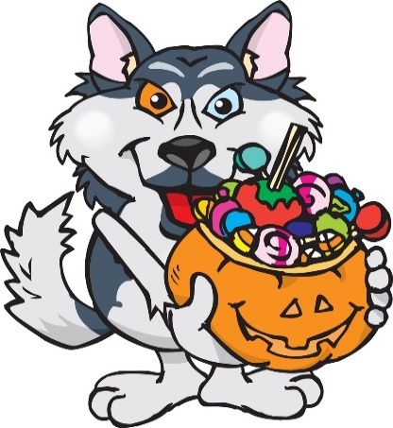
Trunk or Treat
Sunday Oct. 30th
4:00 at Riverside Elementary
Games, Hayrack Ride,
Hot Cocoa, Cookies, and FUN!

*Decorate the back of your vehicle however you wish. Bring enough candy for about 100 kids. The kids can come in their costume. It’s gonna be a great time!
* Line up will begin at 3:45.
*All children must be supervised by an adult.
*A trophy will be awarded to the favorite vehicle, voted on by the kids.
*Questions may be directed to any ESO member or the ESO Facebook Page.
Hosted by Riverside ESO

