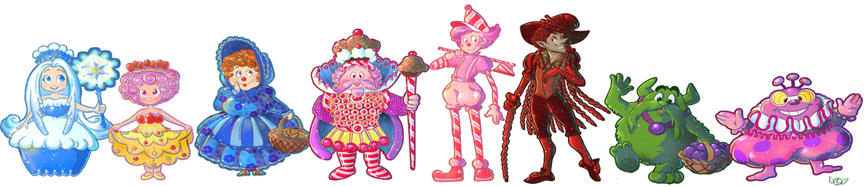
Raffle Ticket Order Form
***Keep this copy, an adult will fill out the actual tickets***
Please see the booklet for descrition of the baskets. Pictures of the baskets can be found on the Highland ESO Facebook page. Tickets are $1 each.
25 tickets = 1 prize choice
*Thank You*
Basket Number
Name |  | Phone | 1 | 2 | 3 | 4 | 5 | 6 | 7 | 8 | 9 | 10 | 11 | 12 | 13 | 14 | 15 | 16/ G | Total
Grandma Example |  | 867-5309 | 2 | 2 |  |  | 2 |  |  |  | 2 |  |  |  | 1 | 1 |  |  | 10

