Please turn in your classroom basket donation by Monday March 20th.
Classroom- Theme- Chair Parent
Preschool Greiner- Summer Fun- Tonya Simpson
Preschool Eaton- Red or Blue- Katie Schneider
Kindergarten- Movie Night- Amanda Goody
1st- Arts and Crafts- Jesi Cole
2nd- Gift Card Frenzy- Lindsey Echrich
3rd- Baking with Kids- Kelly Hazelette
4th- Sleep Over- Misty Herrig
5th- Money Basket- Megan Allen
Some grades have very few items in their basket so we have extended the deadline. Please help to make our raffle a success by donating an item or two! If you do not have time to go shopping, you may send in a monetary donation and class chair parents will go shopping for you.
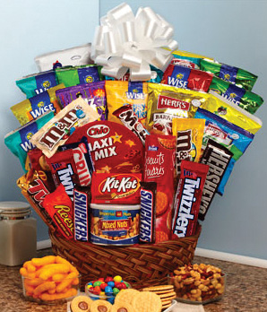
Thank you to all those that have already donated. We appreciate everyone helping us to make Family Game Night a huge success for our kids and the community!

