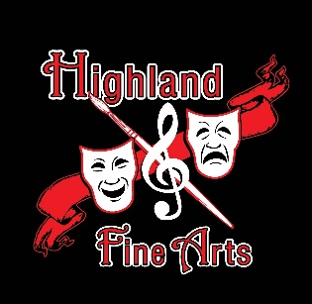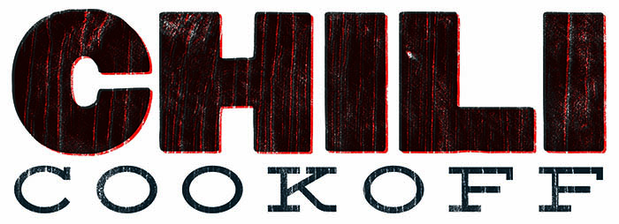
& BINGO Night

Get your stock pots ready for the 2nd annual Fine Arts Chili Cook-off and Bingo games on Friday evening,
February 9th At the Riverside VFW.
(Entries show up at 5:00, tasting/judging starts at 5:30)

All are welcome (and encouraged) to join the Cook-off.
For just $5 you can enter for a prize.
Anyone attending the event will be able to taste the chili and vote for their favorite.

Winner will receive 1 year of bragging rights and a ‘bonus’ Gift
2nd and 3rd place will also be awarded with gifts.

All proceeds will benefit the New York Music trip in April 2018.

Prior sign-up is not necessary, but appreciated for planning.

Please contact Samantha Holden at Mrsholden1278@aol.com or 319-331-9188
to sign up for the chili cook-off or for general questions.

More Details to Come…

