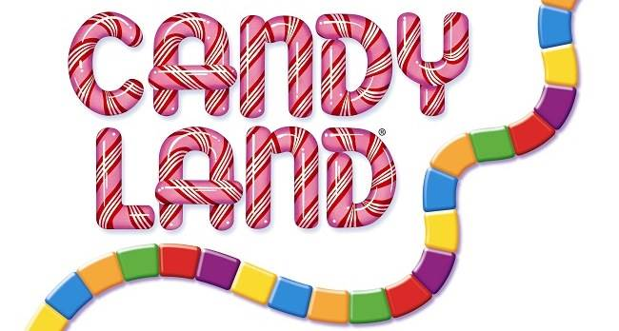
Family Game Night Reminder
Friday May 5th at Riverside Elementary
Dinner at 5:45 Games at 6
Raffle Drawing and Silent Auction closing at 7:45
If your child is done selling raffle tickets, please turn your order form into the office ASAP. We will send the blank raffle tickets home with your child. You can return the completed raffle tickets to the office before noon on May 5th or bring them to the event.
Please come enjoy an evening out with our Highland family!

Family Game Night Reminder
Friday May 5th at Riverside Elementary
Dinner at 5:45 Games at 6
Raffle Drawing and Silent Auction closing at 7:45
If your child is done selling raffle tickets, please turn your order form into the office ASAP. We will send the blank raffle tickets home with your child. You can return the completed raffle tickets to the office before noon on May 5th or bring them to the event.
Please come enjoy an evening out with our Highland family!

