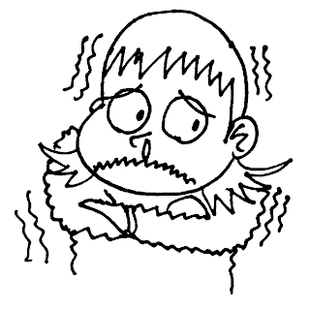

Dear Parent(s):

We hate to see the warm days behind us, but there is no doubt that winter is coming (whether we like it or not)! When students go out for recess (or stand and wait to come inside in the mornings), they tend to get very cold. The playground and blacktop is basically an open field. This means lots of wind and nowhere to hide to get warm.

We are asking that you please make sure that your child comes to school prepared with hats, gloves, coats that zip, and eventually they will need boots and snowpants. Please be sure to label your child’s name in all of them. If you choose a black hat or black gloves, we will not be able to distinguish if they are your child’s belongings or someone else who has lost theirs as well.

Children forget to bring these items from time to time. We have two suggestions:

1. Keep an extra set at school to be left in the locker.
2. Set out the winter gear the night before so your child wears them to school.

Recess will be much more enjoyable if your child has the winter gear to keep them warm. We appreciate your support in this matter.

If you are finding it difficult to purchase these items, please call the school.

Thank You!

Highland Staff

**It’s getting cold outside!!**